***SATNOGS-GDN Group Project***  
Appendix 2: Weekly report – 2019-10-31

This week our team did not do any individual tasks. Instead, we met together and spend half a day assembling the system. We migrated to the new Raspberry Pi 4B platform, replaced old power supply with a new one using USB-C, also put the motherboard into a case. The hardware setup was assembled at Tomek’s apartment. One major problem to solve was how to deploy the system in a way that has good sky visibility from the antenna point of view, has Internet connectivity, has a power supply and the electronics is protected from the weather. After several attempts, we came up with a plan to house the system in the apartment close to a window. The SMA coax cable will go outside through not completely shut down window. The antenna will be deployed on a photographical tripod, standing on a balcony near the window. We also adapted the basic telescope antenna to work a V dipole (53,4cm length, 120 degrees angle). This provisional set-up will be replaced with the ultimate one once the antenna ordered arrives.

We installed several software pieces: GNU Radio, GQRX (both used to control SDR hardware), gpredict (a software that tracks satellites and informs about upcoming fly-overs), NOAA-APT (an open source alternative to wxtoimg software).

We experimented with several fly-overs and finally were able to set up appropriate frequency for NOAA-18, record received transmission as audio and store it as WAV file. The file was then processed using NOAA-API software and generated the following image:

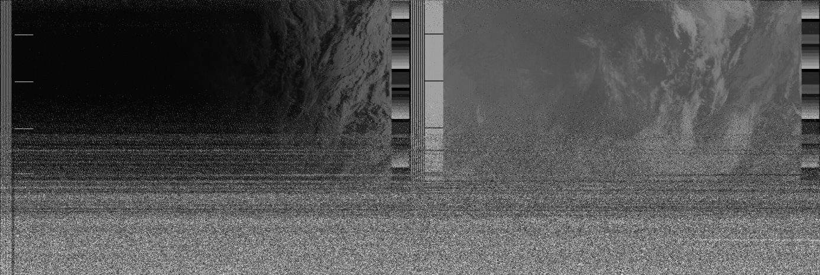

The lower part of the image is garbled, because we went into NLOS (non line-of-sight) mode (part of the sky was obscured by the roof). Nevertheless, we consider this experiment a full success.

We also ordered WiMo TA-1 antenna. According to the vendor, it should be shipped within 4 working days. And indeed a note about its shipment from Germany was received on Oct 31st.